

**Artificial Intelligence and Data Science Department.**

OS / Even Sem 2021-22 / Mock Practicals.

**___________________________________________________**

YASH SARANG.

47 / D6AD.

MOCK PRACTICALS.

**___________________________________________________**

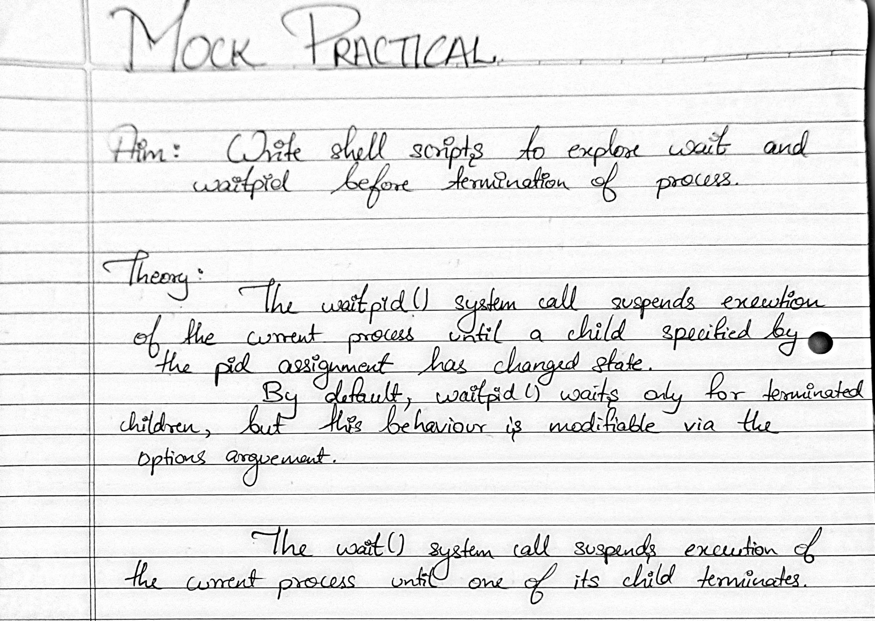

**___________________________________________________**

**___________________________________________________**

**Code:**

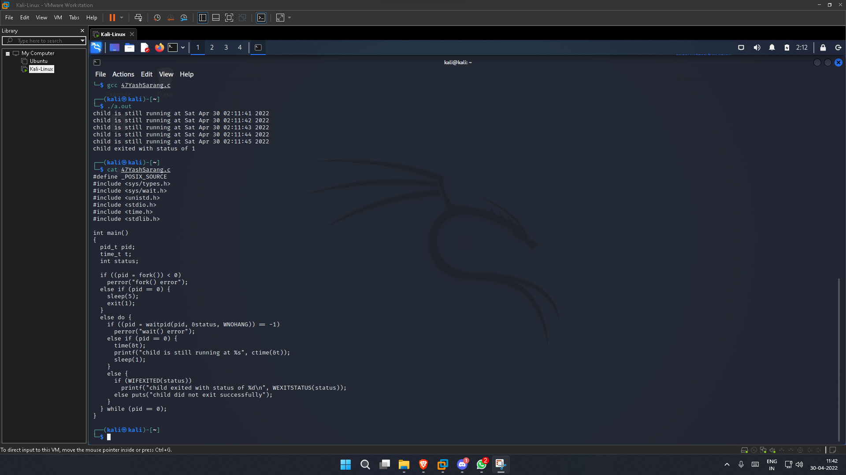

**___________________________________________________**

**Output:**



**Full-Screen ScreenShot:**



**Conclusion:-**

Thus, we have successfully implemented shell scripts to explore wait() and waitpid().

**___________________________________________________**